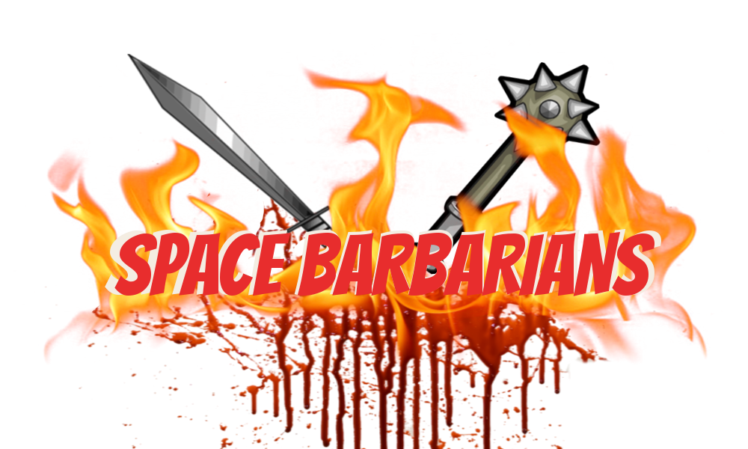

SPACE BARBARIANS© is a fast-paced, 2-player fighting game. In rounds of 01:59 minutes, players must take control of their barbarian and guide him into battle. Engage your enemy, dismember their unworthy body, and take your place in the world of fighting champions in front of an adoring audience!

Play duration: 01:59 minutes per round (maximum)

Number of PlayerS: 2 people per match

How to play: the 2 players must stand, shoulder by shoulder, and control their barbarian from using the keyboard. Player 1 controls (a, d, v) keys, player 2 controls (left, right, enter) keys. The players attack each other’s weapon and limbs, and whoever stands by the end of the match with most limbs still attached is the victor! Should a player dismember their opponent completely before the 01:59 minutes run out, the match ends, and the victor is declared.

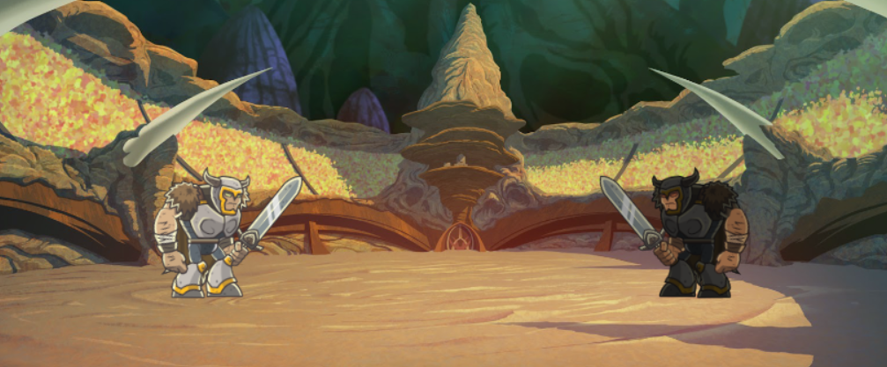

Credit: Victor Olsson, Jonas Christensen, Lorena Ciobanu, RarES Popa, and Marie-Louise Alexius Sørensen.